# EEE109 Lab 1 – Diodes

# (Lab Report)

**Student IDs:** *1928748*

**Submission date:** *Nov 17th, 2020*

### *Abstract*

*In this experiment, we will explore the basic principles of the diode and use its characteristics to verify the regulations of some circuits like clamper and clipper circuits. Then, we will explore the characteristics of two special diodes the Zener diode and limit-emitting circuit. During the lab, we will do seven different experiments to find and verify the diode’s characteristics. After doing all the experiments and analyze all the results, we conclude that the diode could conduct when it is forward-biased and cut off when it is reverse-biased. We can use this characteristic to change the characteristics of the original signal so that the circuit could show more characteristics.*

### Introduction

Diode is a basic component that has been widely used in today’s electronic circuits. A diode can be defined as a two-terminal electronic component which conducts current in one direction (forward-biased) and cuts off in the opposite direction (reverse-biased) [1]. An ideal diode will have no resistance when it is forward-biased, while it will have infinite resistance in the reverse-biased region [1]. In the following experiment, we will further investigate the properties of diode. Then, we will use its characteristics to achieve some goals, such as transforming AC to DC or performing logic operations. After that, we will explore the properties of two kinds of special diodes: Zener diode and light-emitting diode. What is more, another propose of this experiment is to be familiar with practical usage of lab equipment, for instance, multimeter, oscilloscope and function generator, which will also be utilized in future experiments. The next part of the report will show the details of the experiments, including experimental steps, results and some discussion. Finally, there will be a conclusion to summarize all the experiments and show some suggestions which could be helpful to achieve the experiment goals.

### Experimental Procedure

1) Rectification

A) Experimental Steps

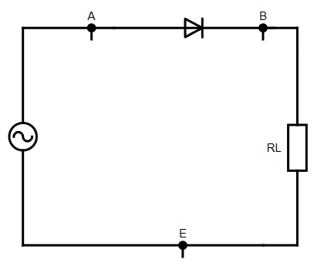 a) Construct the circuit according to Figure 1, the magnitude of input signal is VAE= 10Vpp and frequency is 10kHz. The load resistor RL is 10kΩ.

Figure 1: Rectifier circuit

b) Record the values of VAE and VBE and plot the graphs.

c) Change VAE to 2Vpp and record the values of VAE and VBE. Then, plot the graphs.

B) Results

When VAE = 10Vpp. The signals are shown in Figure 2. 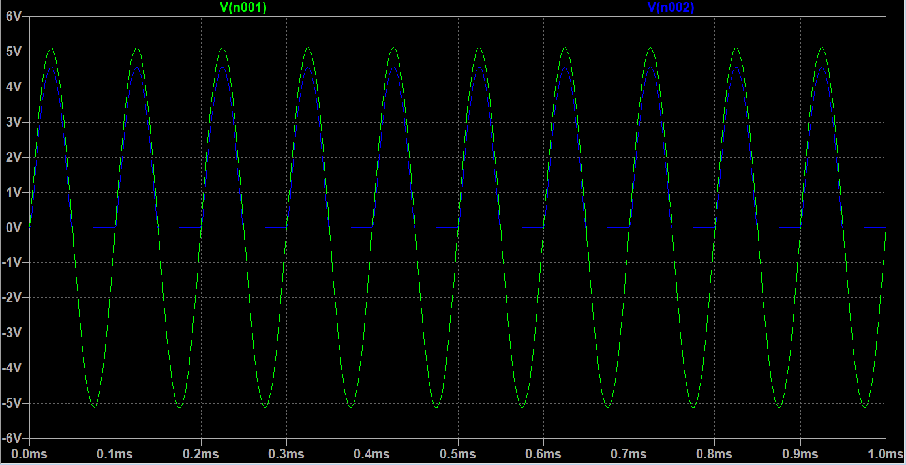

Figure 2: The output signal

(The green one is VAE, the blue one is VBE)

The maximum value of VAE is about 5.12V; the minimum value is about -5.12V

The maximum value of VBE is about 4.46V; the minimum value is about 0V.

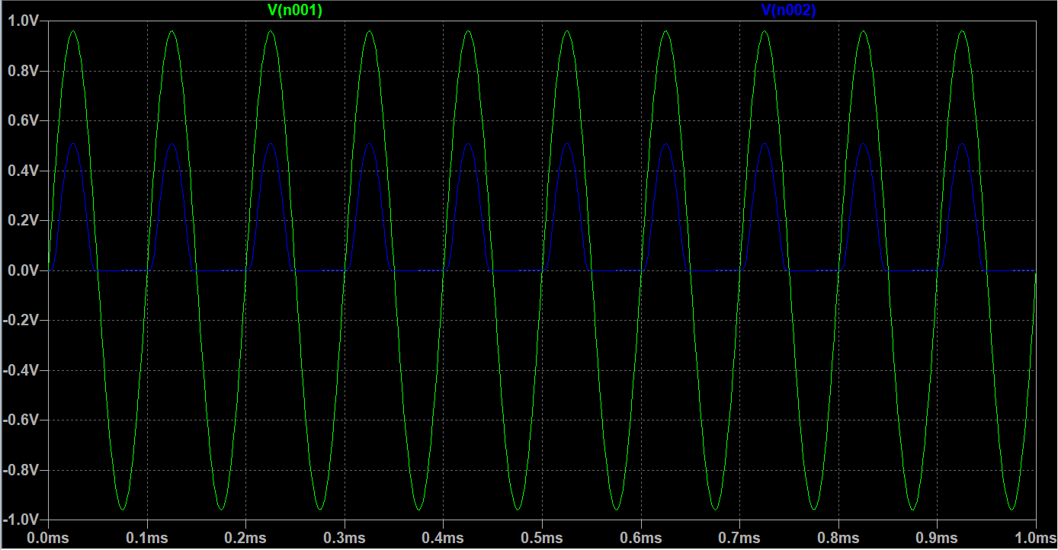 When VAE = 2Vpp. The signals are shown in Figure 3.

Figure 3: The output signal

(The green one is VAE, the blue one is VBE)

The maximum value of VAE is about 0.96 V; the minimum value is about -0.96V.

The maximum value of VBE is about 0.50V; the minimum value is about 0V.

C) Discussion

From Figure 2 and Figure 3, we can find that the diode could control the AC current pass in one direction. That is because the diode will conduct when it is forward biased. Due to the fact that diode has a turn-on voltage, there will be a difference between VBE and VAE. However, when it is reversed biased, the diode will cut off the circuit and there will be no current through the circuit. Thus, the diode can be used as a half-wave rectifier.

2) Smoothed rectifier

A) Experimental steps

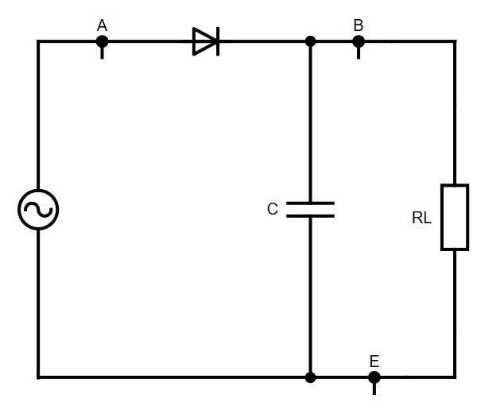 a) Set up the circuit based on the Figure 4, The magnitude of the voltage source VAE is 10Vpp and the magnitude of the capacitor is 100nF. The frequency of the voltage source is 10kHz.

Figure 4: Smoothed rectifier circuit

b) Set the magnitude of RL to 10KΩ. After that, record the values of VAE and VBE and plot the graphs.

c) Change the value of RL to 1KΩ and repeat the step b).

B) Results

When RL = 10KΩ, the graphs of VAE and VBE are shown below:

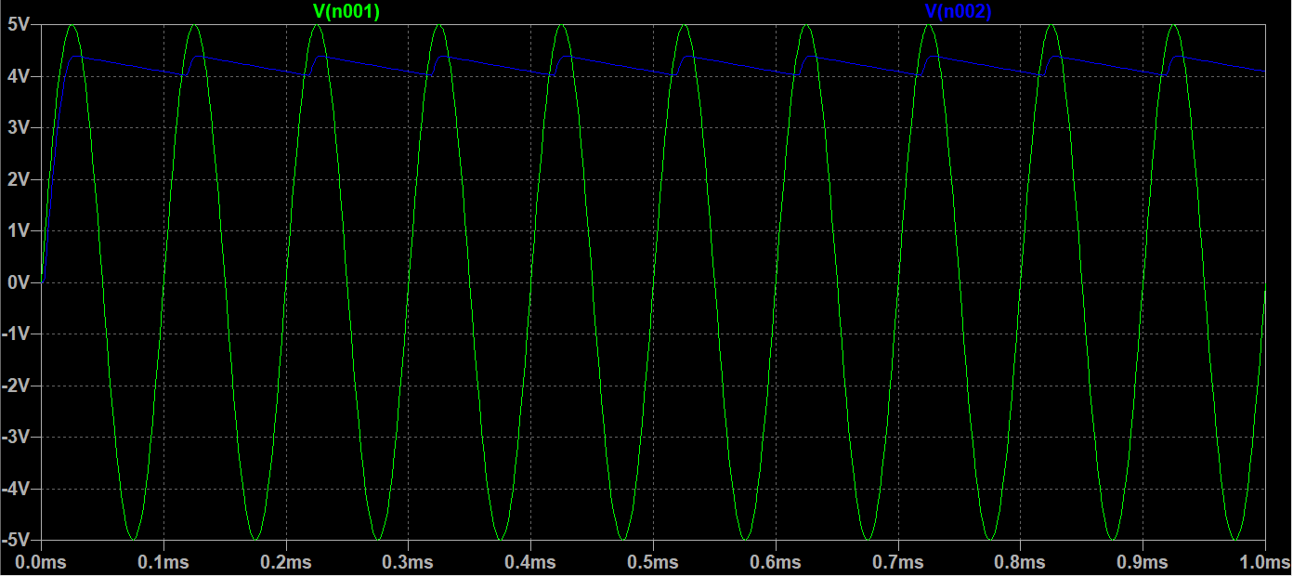

Figure 5: The output signal <1>

(The green one is VAE; The blue one is VBE)

The maximum value and minimum values of VAE are about 4.96V and -4.96V.

The maximum value and minimum values of VBE are about 4.32V and 3.88V.

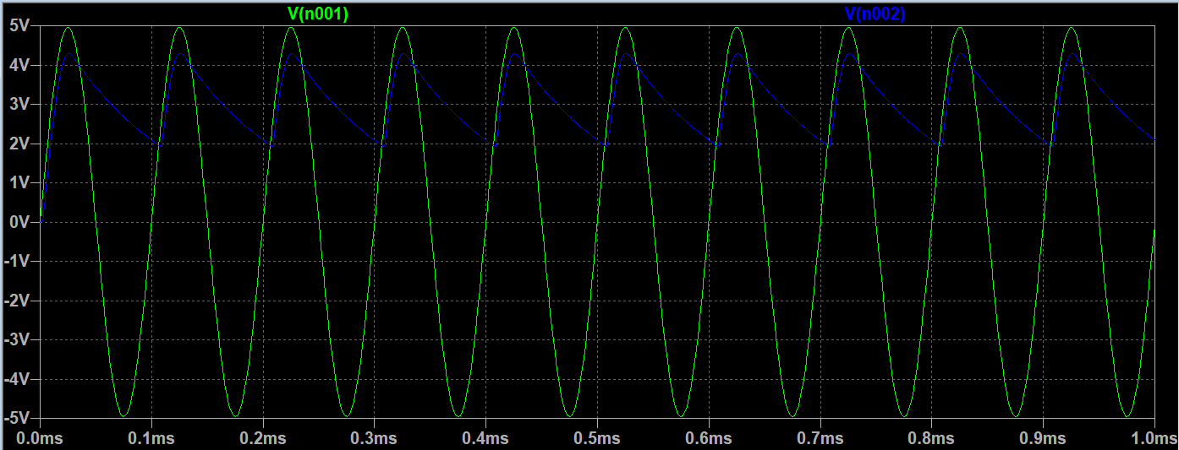 When RL = 1KΩ, the graphs of VAE and VBE are shown below:

Figure 6: The output signal <2>

(The green one is VAE; The blue one is VBE)

The maximum and minimum values of VAE and VBE are about 4.96V and -4.96V.

The maximum and minimum values of VAE and VBE are about 4.48V and 1.94V.

C) Discussion

From Figure 5 and Figure 6, we can find that the capacitor can reduce the change of the voltage. That is because the capacitor will charge to its peak value when the input volage at peak voltage. When the input voltage decreases, the diode becomes reverse-biased. The capacitor will discharge through the resistor RL. Therefore, the change of VBE will be decreased. What is more, we can also find that the larger the resistance selected, the more stable the output waveform will be.

3) Limiter/Clipper

A) Experimental steps

a) Construct the circuit according to Figure 7. Make sure that VA = 10Vpp and frequency f = 10kHz.

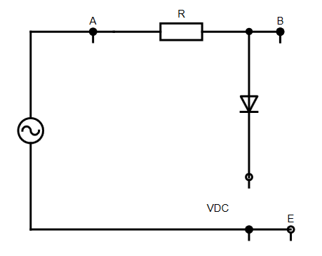 The magnitude of the resistance is 1KΩ.

Figure 7: The Clipper circuit.

b) Set VDC = 0V. Plot the graphs of the input and output signals.

c) The change the magnitude of VDC to +3V and repeat step b).

d) As for c) but change the diode from forward biased to reverse biased.

B) Results

When VDC = 0V, the graph is shown below: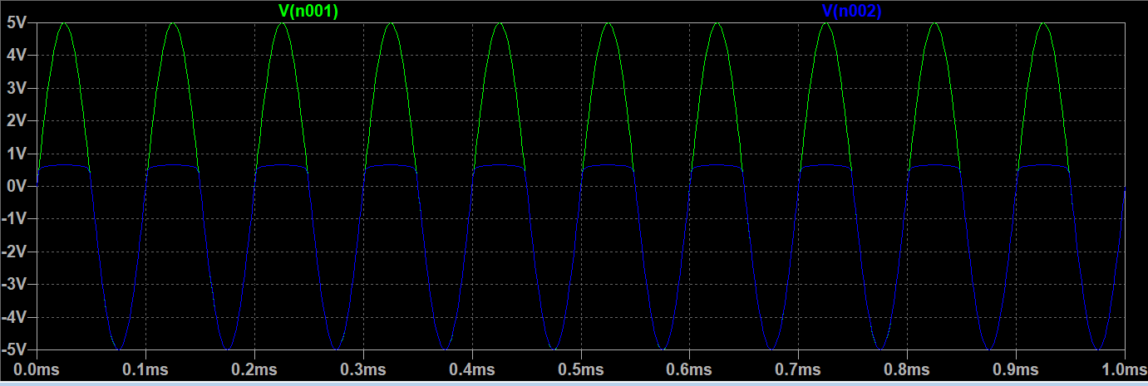

Figure 8: The output and input signal <3>

(The green one is input; The blue one is output)

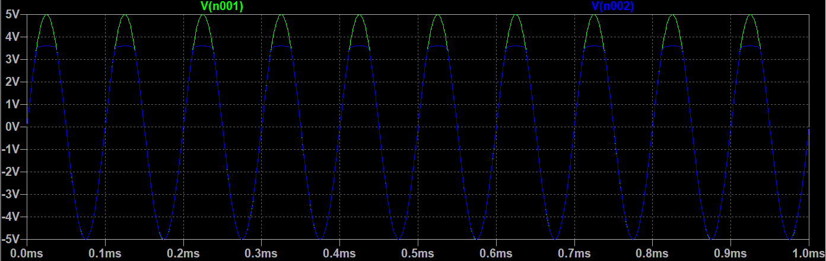 When VDC = +3V, the graph is shown below:

Figure 9: The output and input signal <4>

(The green one is input; The blue one is output)

When the diode is reverse-biased. The graph is shown below: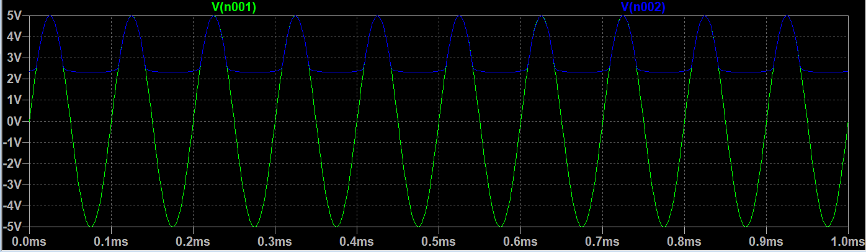

Figure 10: The output and input signal <5>

(The green one is input; The blue one is output)

C) Discussion

The graphs show that the clipper circuit could prevent the output from exceeding a predetermined voltage level without influence the remaining part of the signal. If the AC voltage is larger than 0.7V, the output voltage is just the conducting voltage of the diode, which is about 0.7V. If a +3V DC voltage is applied (Figure 9), the output voltage is the total of conducting voltage and the DC value, which is about 3.7V when the AC voltage is larger than 3.7V. When the diode is reverse-biased (Figure 10), the circuit will be cut-off if the AC voltage could not supply enough voltage. Thus, only the DC voltage will supply energy. Therefore, the output voltage is about 2.3V. However, when the AC supply is larger than 2.3V, the output will be the AC voltage.

4) Voltage Clamper

A) Experimental steps

a) Construct the circuit according to Figure 11, make sure the voltage source is 10Vpp, and the frequency is 10kHz. Moreover, the magnitude of the capacitor is 100nF.

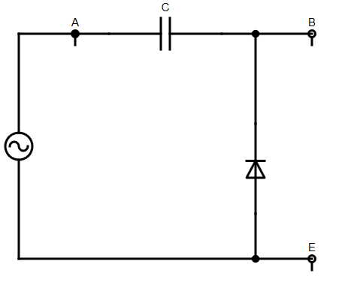Figure 11: The clamper circuit

b) Record the maximum and minimum values of VA and VB and plot the graphs.

c) As for step b), but reverse the diode terminals.

B) Results (Ignore the capacitor charging time)

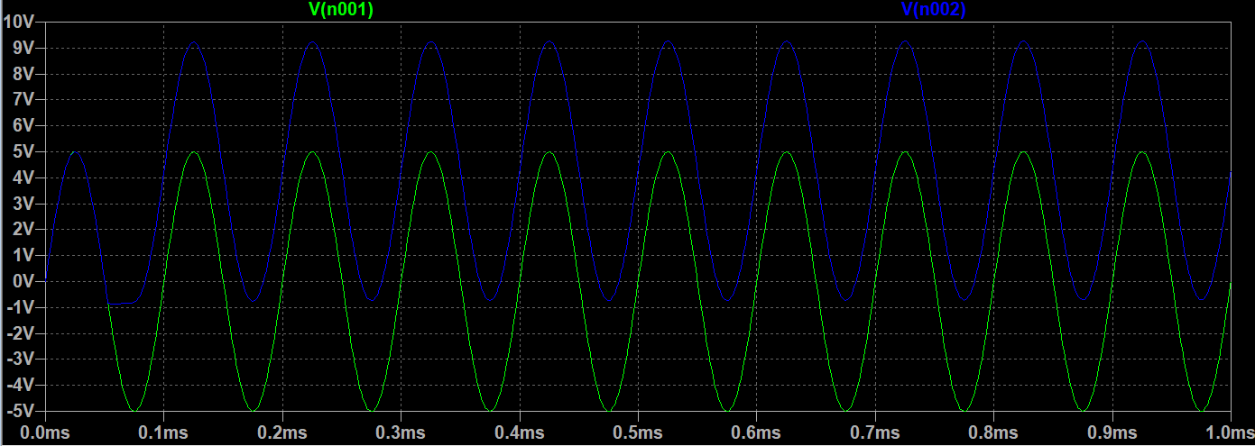 When the diode is reverse-biased, the graph is shown below.

Figure 12: The output signal <6>

(The green one is VA; The blue one is VB)

The maximum value of VA is 4.96V. The minimum value of VA is -4.96V.

The maximum value of VB is 9.4V. The minimum value of VB is -0.8V.

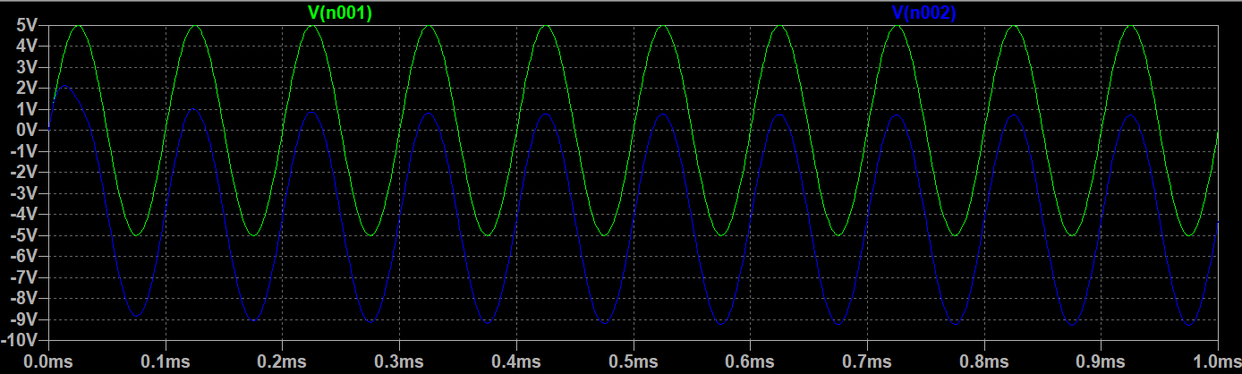 When the diode is forward-biased, the graph is shown below.

Figure 13: The output signal <7>

(The green one is VA; The blue one is VB)

The maximum value of VA is 4.96V and the minimum value of VA is 4.96V.

The maximum value of VB is 0.8V and the minimum value of VB is -9.32V.

C) Discussion

From Figure 14 and Figure 15, it is clear that the output signal is shifted by a DC value. That is

because the capacitor was fully charged. Then, the DC level of the original signal will be changed. Besides, it will not change other features of the original input signal.

5) Diode logic

A) Experimental steps

a) Construct the circuit according to Figure 14. The magnitude of VDC is +5V. The value of R1 and

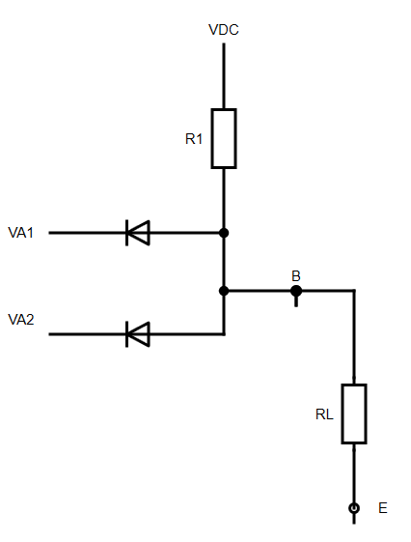RL are 2.2kΩ and 10kΩ.

Figure 14: The diode logic circuits

b) Set VA1 = VA2 = +5V, and record the value of VB.

c) Set VA1 = 0V volt and VA2 = +5V. Then, record the value of VB.

d) Set VA1 = +5V and VA2 = 0V. Write down the value of VB.

e) Change VAI and VA2 to 0V and write down the magnitude of VB.

B) Results and discussion

The value of VB is shown in Table 1

|  |  |
| --- | --- |
| The magnitude of VA1 and VA2 | VB |
| VA1 = VA2 = +5V | 4.151V |
| VA1 = 0V VA2 = +5V | 0.63V |
| VA1 = +5V VA2 = 0V | 0.64V |
| VA1 = VA2 = 0V | 0.59V |

Table 1

From Table 2, we can find that the circuit is an AND logic circuit.

|  |  |  |
| --- | --- | --- |
| A1 | A2 | B |
| +5 (high) | +5 (high) | 4.151 (high) |
| 0 (low) | +5 (high) | 0.63 (low) |
| +5 (high) | 0 (low) | 0.64 (low) |
| 0 (low) | 0 (low) | 0.59 (low) |

Table 2

6) Zener Stabiliser

A) Experimental step

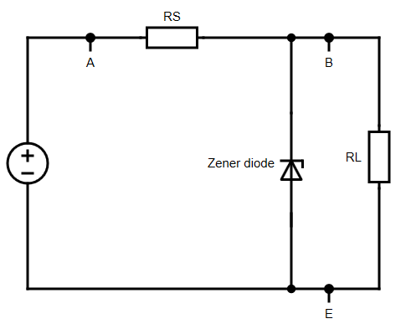 a) Construct the circuit according to Figure 15. The breakdown voltage of Zener diode is 10V and the series resistance RS is 1kΩ.

**VDC**

Figure 15: Zener Stabiliser Circuit

b) Set RL to open circuit. Vary the value of VDC from 0V to 20V in 2 volts steps, and measure the values of VB and VDC.

c) Set VDC as 20V. Record the value of VB when RL = 3.3kΩ, 1.5kΩ, 1kΩ and 820Ω. Then, calculate the value of the load current based on IL = VB/RL.

B) Results

When RL is open circuit. The value of VB and VDC are shown in Table 3.

|  |  |  |  |  |  |  |  |  |  |  |  |
| --- | --- | --- | --- | --- | --- | --- | --- | --- | --- | --- | --- |
| VDC (V) | 0 | 2 | 4 | 6 | 8 | 10 | 12 | 14 | 16 | 18 | 20 |
| VB (V) | 0 | 2.0004 | 4.033 | 6.021 | 8.043 | 9.916 | 10.014 | 10.069 | 10.11 | 10.151 | 10.184 |

Table 3

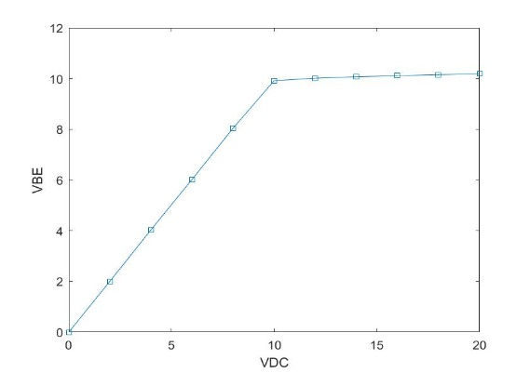The graph of VB against VDC is shown below:

Figure 16: The output graph

When RL is equal to a constant value, the value of VB and VDC are shown in Table 4:

|  |  |  |
| --- | --- | --- |
| RL (Ω) | VB (V) | IL (mA) |
| 1.5k | 10.084 | 6.723 |
| 3.3k | 10.176 | 3.084 |
| 0.82k | 8.936 | 10.098 |
| 1k | 9.93 | 9.93 |

Table 4

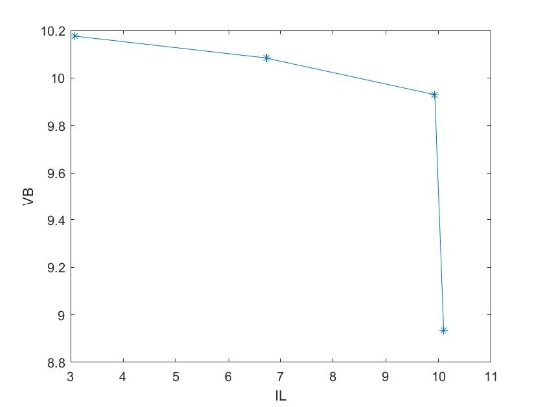 The graph of VB against IL is shown below:

Figure 17: The output graph

7) Light-emitting diodes

A) Experimental step

a) Construct the circuit according to Figure 18. Set the magnitude of the voltage source as 10Vpp

square wave and frequency f = 2Hz. The resistor R is equal to 330Ω.

b) Plot the graph of the input and output signal.

B) Results

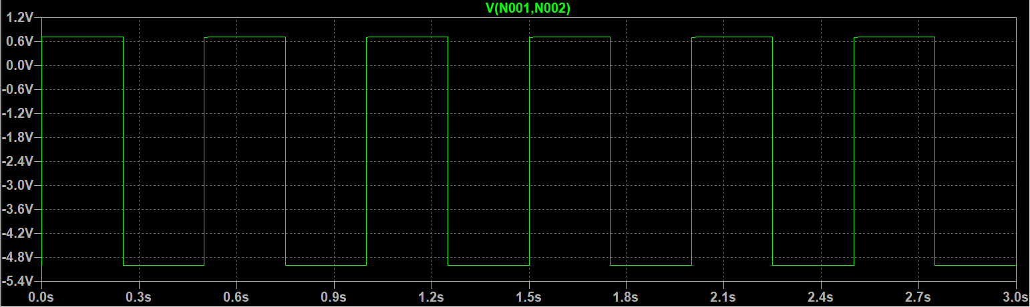 The graph is shown below:

Figure 18: The output signal <8>

The maximum value is about 0.7V. The minimum value is about -4.96V.

### Conclusions

In conclusion, we explore the basic properties of diode and use its properties to verify the conclusions of some circuits, for example, rectifier circuit, clamper circuit, clipper circuit and diode logic operations. From these circuits, we find that diode can be used to change and adjust the characteristics of the original input signal. Thus, we can use diode to obtain an output signal which we would like it to be. What is more, we also explore the characteristics of some special diode, such as Zener diode and light-emitting diode. In the breakdown region, Zener diode can remain the output voltage stable although the input voltage may vary greatly. We can also find that LED could transfer the electrical signals to light signals. In the end, there are some notices that I consider we should be paying attention when we are doing experiments. Firstly, you should make sure every component could work normally, for instance, doing calibration before using oscilloscope and multimeter. If you do not check all the components, there could be a large error between the theoretical values and the experimental values. Secondly, you had better use the simulation software to stimulate the experimental circuit after the experiment. That is helpful to verify the experimental results.

### References

[1] Components101, *Introduction to Diodes: Basics, Types, Characteristics, Applications & Packages*,2018. [online].Available: <https://components101.com/articles/introduction-to-different-types-of-diodes> [Accessed Nov. 6, 2020].

### Appendix A: Graphics:

This part shows some screenshots when our group was doing the experiments, all of the screenshots will be cited with “<>” in the third part of the report so that you will know what kind of experiment the screenshot shows.

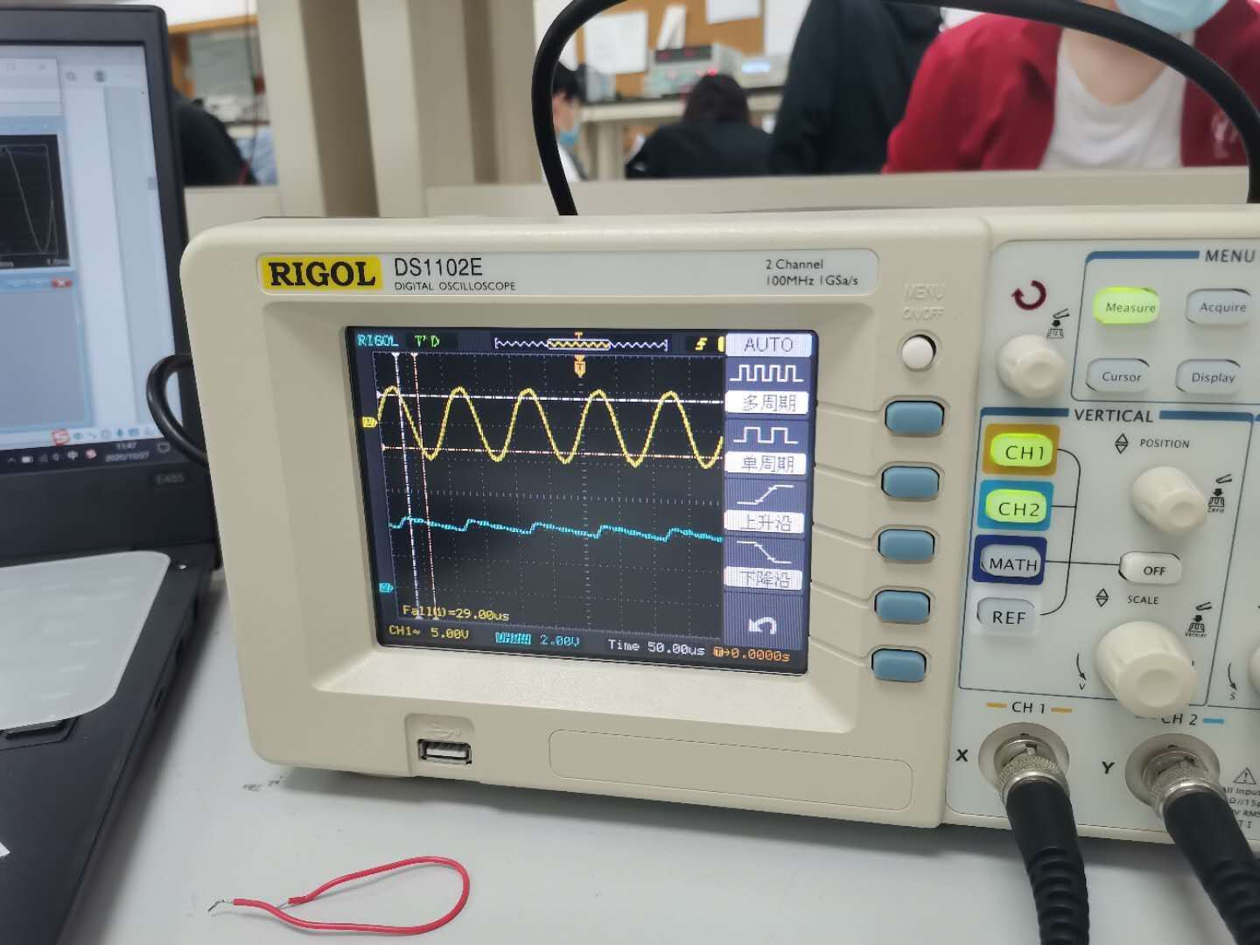<1>.

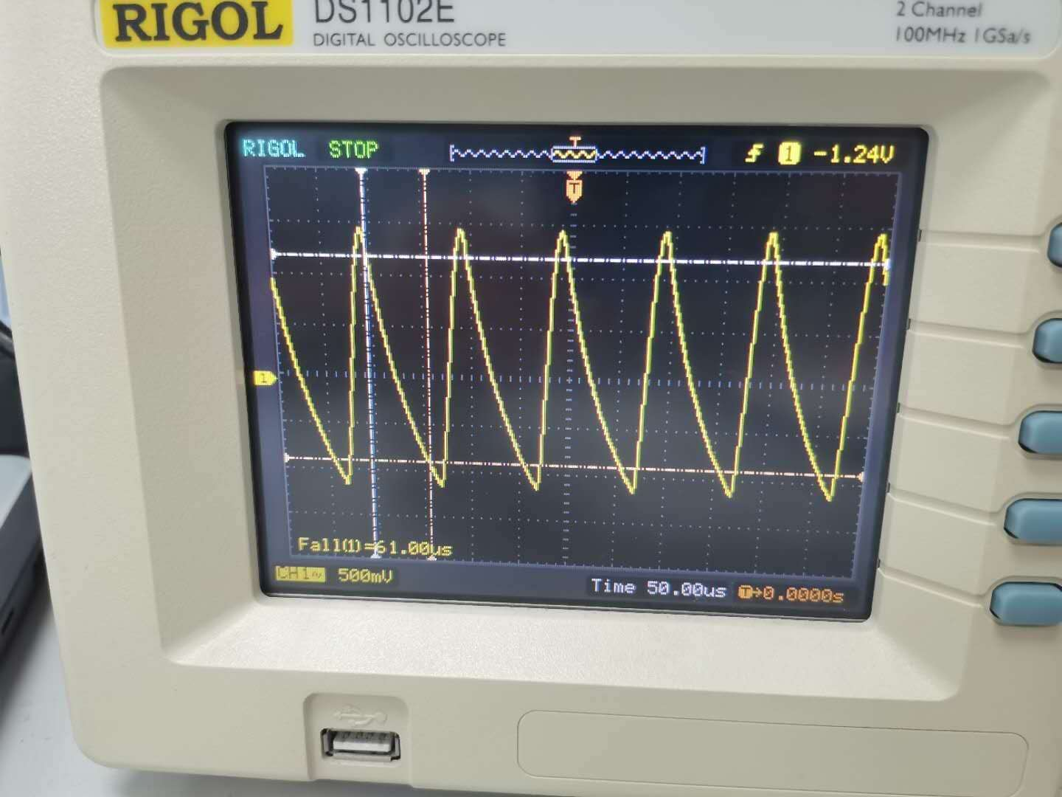<2>.

<3>.

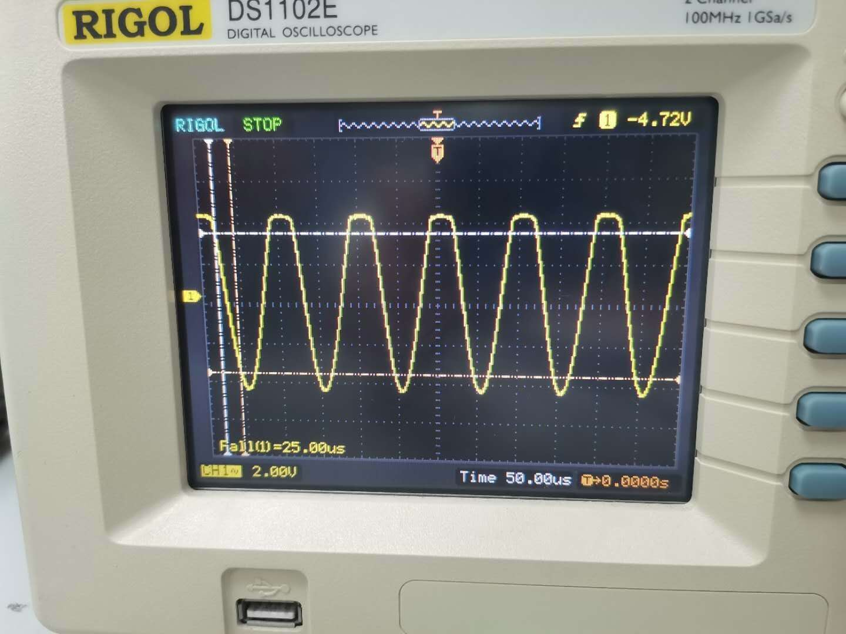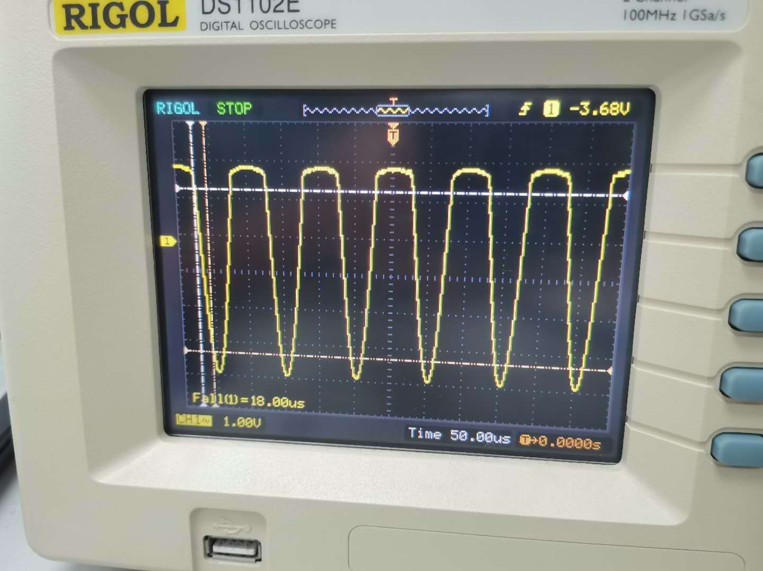<4>.

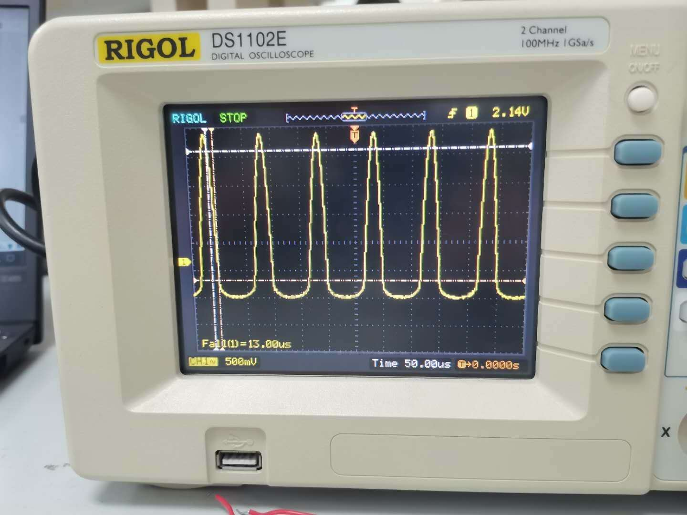<5>.

<6>.

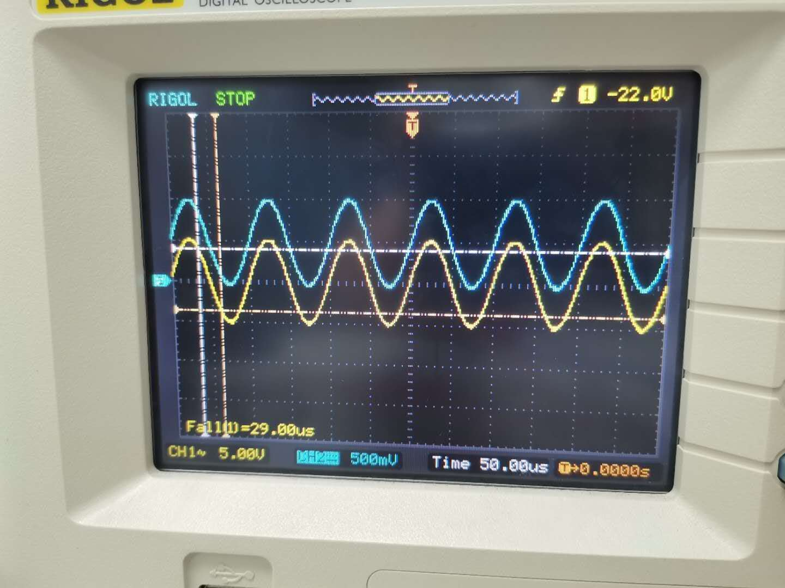

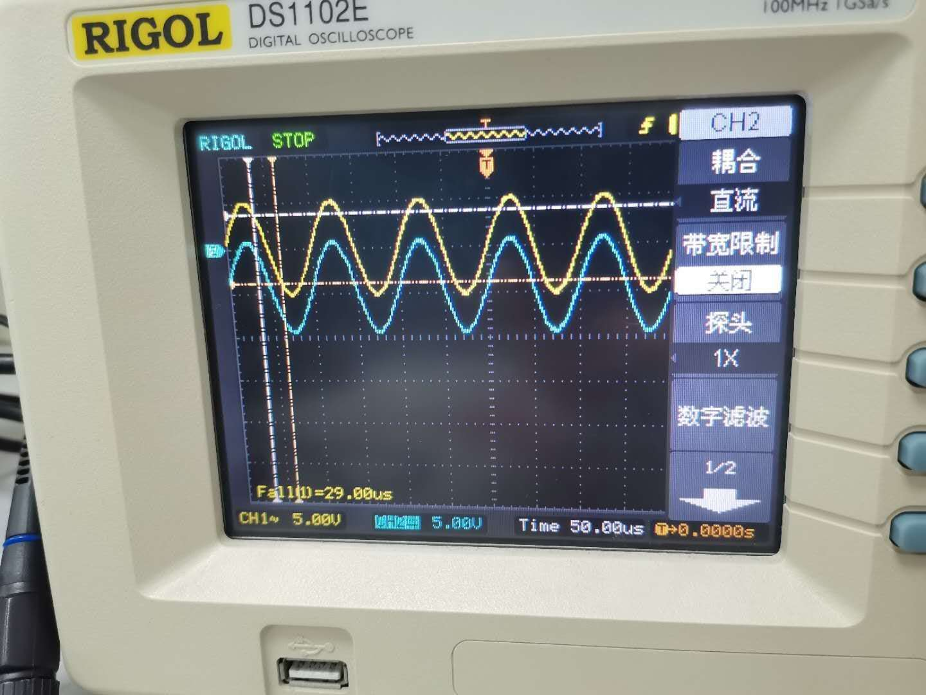<7>.

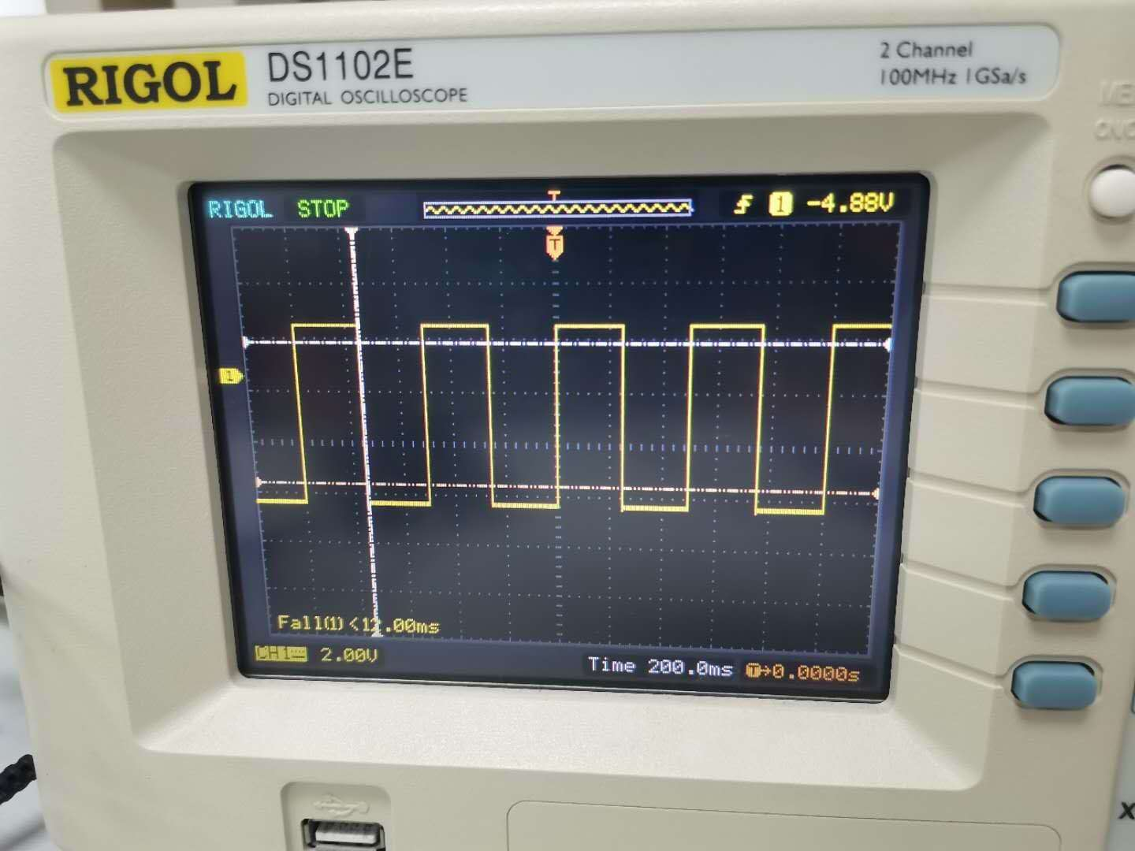<8>

### Appendix B: ****Marking Scheme****

|  |  |
| --- | --- |
| **Marks** | **Sections** |
| **5%** | Abstract |
| **10%** | Introduction |
| **70%** | Experimental Procedure |
|  | Rectification (10%) |
|  | Smoothed rectifier (10%) |
|  | Limiter/Clipper (10%) |
|  | Voltage Clamper (10%) |
|  | Diode logic (10%) |
|  | Zener Stabiliser |
|  | Light-emitting diodes (10%) |
| **15%** | Conclusion |